- Retrieve employee number, NI number, and department number for all employees.
Query: SELECT DepNo, NiNo, EmpNo FROM employee
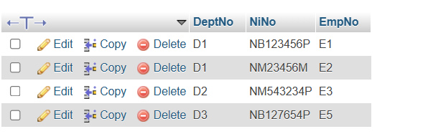
- Retrieve the full names of all employees
Query: SELECT Firstname, Surname FROM employee
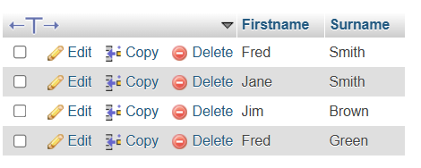
- Retrieve a list of all the distinct employee surnames.
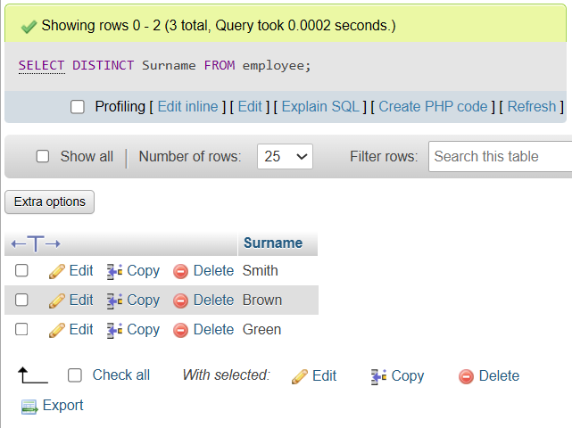
- Retrieve NI numbers for all employees called Smith.
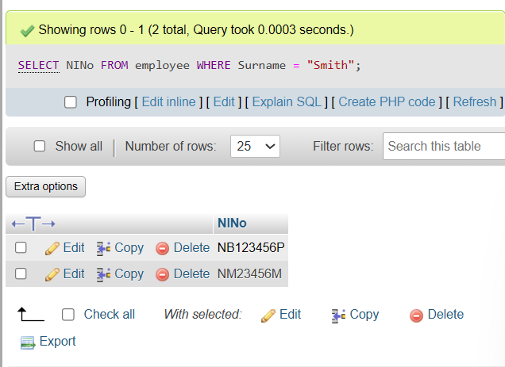
- Retrieve the NI of employees who do not work in department D2.
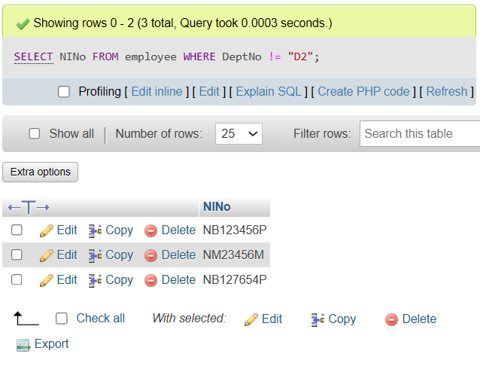
- Retrieve details of employees whose surnames start with the letters Sm.
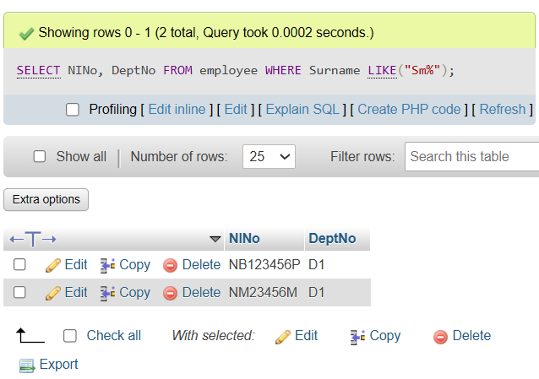
- Retrieve for each employee their names and their monthly salary.
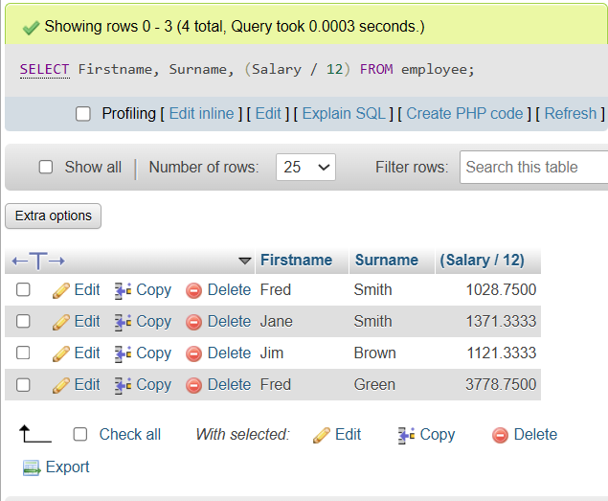
- Retrieve the average employee salary, the salary of the lowest paid employee, and the salary of the highest paid employee.
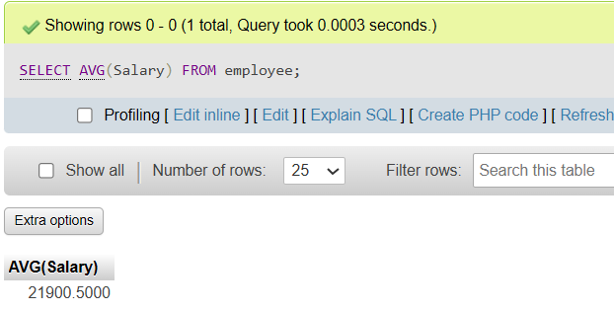
- Retrieve the full names of employees and the names of the departments within which they work.
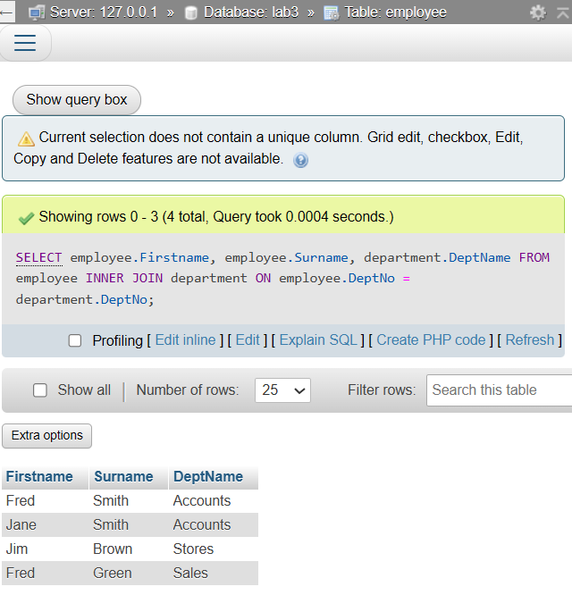
10. Retrieve the full names of employees, the names of the departments within which they work and their telephone extension.

